GURU NANAK FOUNDATION, MOHALI
List Of Books (Session 2024-2025)
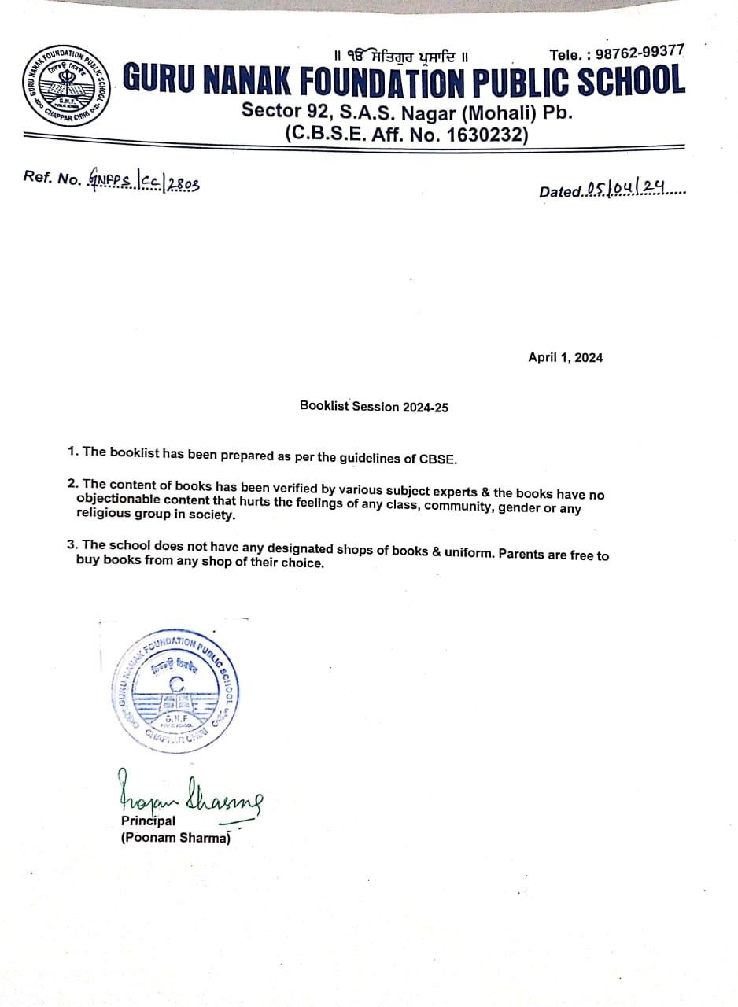

CLASS:NURSERY
S.no | Name Of Book | Session (2024-25) | Session (2023-24)
1 | Next Book Set | Same as current session
2 | Practice English Primer
3 | Practice Number Primer
4 | Art Primer

CLASS: KG 1
S.no | Name Of Book | Session (2024-25) | Session (2023-24)
1 | Next LKG Book Set | Same as current session
2 | Practice Number Primer A
3 | Practice English Primer A
4 | Hindi Primer A
5 | Art Primer A

CLASS: KG 2
S.no | Name Of Book | Session (2024-25) | Session (2023-24)
1 | Next UKG Book Set | Same as current session
2 | Practice English Primer B
3 | Practice General Primer B
4 | Practice Number Primer B
5 | Art Primer B
6 | Hindi Primer B Pustak A
7 | Hindi Primer B Pustak B
8 | Akhar Gyan Punjabi

CLASS:1st
S.no | Name Of Book | Session (2024-25) | Session (2023-24)
1 | Semester Book Sem 1 | Same as current session
2 | Semester Book Sem 2
3 | Art 1
4 | Hindi 1
5 | Hindi Sulekh 1
6 | Cursive 1
7 | English Grammar 1
8 | Punjabi Praveshka

CLASS:2nd
S.no | Name Of Book | Session (2024-25) | Session (2023-24)
1 | Semester Book Sem 1 | Same as current session
2 | Semester Book Sem 2
3 | Art 2
4 | Hindi 2
5 | Hindi Sulekh 2
6 | English Cursive 2
7 | English Grammar 2
8 | Punjabi 2

Class:3rd
S.no | Name Of Book | Session (2024-25) | Session (2023-24)
1 | Semester Book Sem 1 | Same as current session
2 | Semester Book Sem 2
3 | English Grammar 3
4 | Art 3
5 | Hindi 3
6 | Punjabi 3
7 | Computer 3 Uolo

Class:4th
S.no | Name Of Book | Session (2024-25) | Session (2023-24)
1 | Semester Book Sem 1 | Same as current session
2 | Semester Book Sem 2
3 | English Grammar 4
4 | Art 4
5 | Hindi 4
6 | Hindi Vyakaran 4
7 | Punjabi 4
8 | Punjabi Vyakaran 4
9 | Computer 4 Uolo

Class:5th
S.no | Name of book | Session (2024-25) | Session (2023-24)
1 | Semester Book Sem 1 | Same as current session
2 | Semester Book Sem 2
3 | English Grammar 5
4 | Art 5
5 | Hindi 5
6 | Hindi Vyakaran 5
7 | Punjabi 5
8 | Punjabi Vyakaran 5
9 | Computer 5 Uolo

Guru Nanak Foundation Public School Sector 91 Mohali
Session 2024-2025
CLASS 6
BOOK LIST |  |  | Session (2024-25) | Session (2023-24)
1 | English | NCERT Honeysuckle- Textbook in English for Class VI | Same as current session
 | Supplementary Reader | NCERT A Pact with the Sun- Supplementary Reader in English  forClass VI
2 | Math | NCERT TEXT BOOK
3 | Hindi | NCERT Vasant – bhaag 1
 |  | NCERT Baal Ramkatha- for class-6
4 | Science | NCERT TEXT BOOK
5 | S.St | NCERT Textbook Social Studies Class 6
6 | Punjabi | Gyan Rishma Pustak Part-3 (Optional to purchase for reference)

Guru Nanak Foundation Public School Sector 91 Mohali
Session 2024-2025
CLASS 7
BOOK LIST |  |  | Session (2024-25) | Session (2023-24)
1 | English | NCERT Honeycomb- textbook in English for Class VII | Same as current session
 |  | NCERT AN ALIEN HAND-SUPPLEMENTARY READER
2 | Math | NCERT TEXT BOOK
3 | Hindi | NCERT Baal Mahabharat - for class-7
 |  | NCERT Vasant – bhaag 2
4 | Science | NCERT TEXT BOOK
5 | S.Studies | NCERT TEXT BOOK Social Studies Class 7
6 | Punjabi | Suche Moti Part 7 (Optional to purchase for reference)

Guru Nanak Foundation Public School Sector 91 Mohali
Session 2024-2025
CLASS 8
BOOKS LIST |  |  | Session (2024-25) | Session (2023-24)
1 | English | NCERT Honey Dew- Textbook in English for Class VIII | Same as current session
 | SUPPLEMENTARY READER | NCERT It so happened- Supplementary Reader in English for ClassVIII
2 | Math | NCERT TEXT BOOK
3 | Hindi | NCERT Vasant – bhaag 3
 |  | (NCERT Barat ki khoj – for class-8
4 | Science | NCERT textbook
5 | S.St | NCERT Textbook Social Studies Class 8
6 | Punjabi | Suche Moti Part 8 (Optional to purchase for reference)

Guru Nanak Foundation Public School Sector 91 Mohali
Session 2024-2025
CLASS 9
BOOKS LIST |  |  | Session (2024-25) | Session (2023-24)
1 | English | NCERT Textbook Class 9 (Beehive and Moment) | Same as current session
2 | Math | NCERT TEXT BOOK  Lab Manual Mathematics WITH PRACTICAL FILE
3 | Hindi | NCERT Sanchyan- Baag- 1 for class- 9, NCERTSparsh Bhaag-1,
4 | Science | NCERT  textbook Practics  Noteboo k
5 | S.St | NCERT Textbook Class 9
6 | Punjabi | NCERT Books Literature books -Sahitik Rang-1 Sahitik Kirna 1

Guru Nanak Foundation Public School Sector 91 Mohali
Session 2023-2023
CLASS 10
BOOKS LIST |  |  | Session (2024-25) | Session (2023-24)
1 | English | NCERT Textbook Class 10  FIRST FLIGHT & FOOTPRINTS WITHOUT FEET | Same as current session
2 | Math | NCERT TEXT BOOK  Laboratory Manual WITH PRACTICAL FILE
3 | Hindi | NCERT Sanchyan- Baag- 2 for class 10 , NCERT Sparsh Bhaag-2
4 | Science | NCERT TEXT BOOK
 |  | Practicals Notebook
5 | S.St | NCERT Textbook Class 10
6 | Punjabi | NCERT Sahitik Kirna-2 Sahitik Rang-2 NCERT

